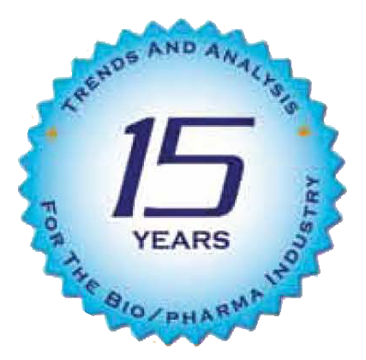

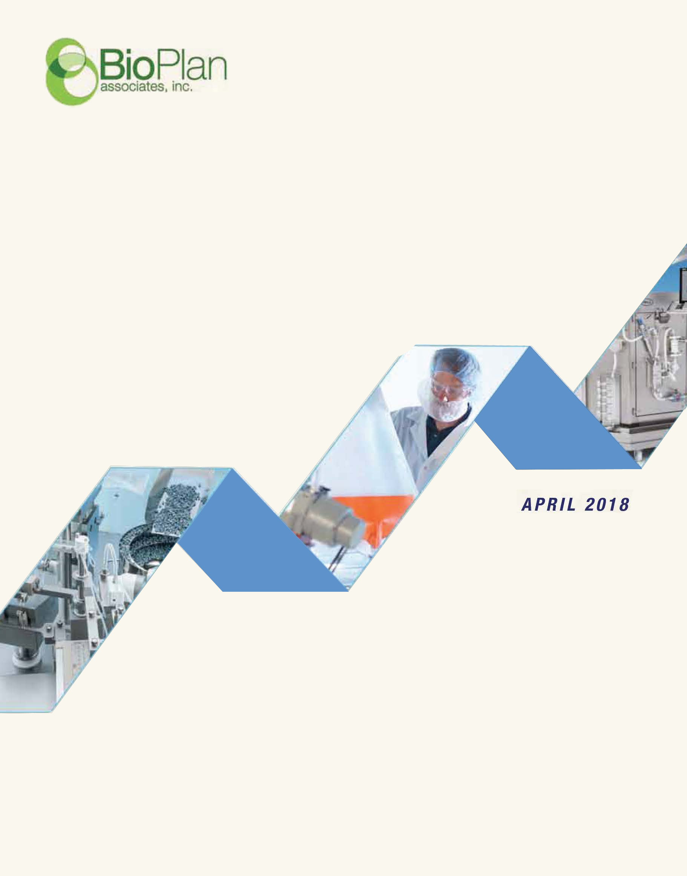

Abstract: This review of the Top 15 Trends in Biopharmaceutical Manufacturing (bioprocessing) provides top-level trends information primarily from the 15th Annual Report and Survey of Biopharmaceutical Manufacturing Capacity and Production, April 2018, published by BioPlan Associates.¹ We have drawn these insights and the ranking of trends based on an internal analysis of the most commonly discussed industry problems, and with input from BioPlan’s Biotechnology Industry Council™, an advisory panel of over 700 global biopharma industry subject matter experts.
For information, visit: www.bioplanassociates.com/15th/.
Note: figures presented are partial representations; full data can be viewed in the report

Top 15 Trends in Biopharmaceutical Manufacturing, 2018

A Summary of Current Major Trends Affecting Biopharmaceutical Manufacturing from the 15th Annual Report and Summary of Biopharmaceutical Manufacturing Capacity and Production
July 2018
©2018 BioPlan Associates, Inc., All Rights Reserved

INTRODUCTION
The biopharmaceutical industry is dynamic and complex, and BioPlan’s 2018 15th Annual Report and Survey of Biopharmaceutical Manufacturing indicates that the industry and related opportunities continue to expand. As part of our annual analysis of biopharmaceutical manufacturing, this year we surveyed 222 biopharmaceutical decision-makers at developer and contract manufacturing organizations (CMOs) in 22 countries. To assess industry growth and challenges from the suppliers’ perspective, we also surveyed 130 industry vendor respondents. This study quantitatively evaluates the current industry situation, and where it is going. This summary Trends Analysis provides insights into the broad trends experienced by the industry, including:
- Industry size, growth, number of products, etc.
- Demand for efficiency
- International biomanufacturing centers
- Cell and gene therapy trends
- Hiring and training of staff

Quantified trends in the 15th Annual evaluation of biomanufacturing include:
- Manufacturing efficiency and productivity
- Bioprocessing productivity continues to increase
- Biosimilars/biogenerics bringing more products and players
- Facility Constraints creating bioprocessing bottlenecks
- Industry seeks lower manufacturing costs
- Healthy Biopharma Industry and Supplier Growth
- Bioprocessing budgets continue to increase
- Single-use systems use still growing
- Continuous bioprocessing innovation in demand
- Bioprocessing capacity growing in Asia; & in cell therapy
- Hiring in bioprocessing a continuing problem
- Fill-finish operations are advancing
- Analytical assays a top area needing improvement
- China on track to become an industry leader
- Changing concerns when selecting a CMOs

Overall, the pharmaceutical industry and its and biopharmaceutical subset remain active and profitable. There are estimated to be well over 10,000 therapeutics in R&D, both drugs (chemical substances) and biopharmaceuticals (biotechnology-derived pharmaceuticals), with nearly 40,000 ongoing clinical trials. Among these, >40% or well over 4,000 candidate pharmaceuticals in R&D are biopharmaceutical, large molecule products. A significant portion, about 1,400 products, in the development pipeline, are follow-on biopharmaceuticals, mostly biosimilars. With overall steady growth in revenue, the worldwide biopharmaceutical industry is continuing to grow and expand, with the most rapid growth in developing countries.

FUTURE TRENDS IN THE BIOPHARMACEUTICAL INDUSTRY
The biopharmaceutical industry is continuously growing, evolving and demanding new and improved bioprocessing technologies to reduce costs, increase efficiencies, and improve weak development pipelines, especially in developing economies. Many of the largest pharmaceutical companies today are devoting increasing development efforts to biopharmaceuticals rather than small molecule drugs.
In fact, multiple sources report that most are spending 40%-50% of their R&D on biopharmaceuticals. And there continues to be a very strong component of smaller, mostly innovation-oriented biopharmaceutical developer companies. Facilitating this trend of growth, are the incremental innovations in improved manufacturing productivity. These are a driver for many biopharmaceutical advances. Innovation also speeds discovery, increases manufacturing strategy options, and can drive down costs and improve overall productivity. The current situation in biopharma is exciting, with new technologies and markets, such as biosimilars, cellular and gene therapies, and many new opportunities in emerging markets.

We project an optimistic future vision that includes the likelihood of more:

- Biopharma facilities worldwide, especially in major markets and Asia
- Biological products, but often each with smaller markets
- Follow-on products and manufacturers, including biosimilars and biogenerics
- Flexible manufacturing facilities, including use for manufacture of multiple products
- Modular facilities
- Cloned facilities in developing countries
- Regional cellular/gene therapies manufacturing
- Adoption of single-use systems at clinical, and ultimately commercial scale production
- Efficiency in bioprocessing as titers and yields continue to increase
- Use of continuous processing, including for downstream processing
- Diverse products in development and marketed, e.g., cellular and gene therapies
- Automation, monitoring and process control
- Use of bioprocess modeling, data mining, PAT, QbD, etc.
- Use of high-tech expression systems and other genetic engineering advances
- Complex regulations which drive many other specific needs and advances

These bioprocessing innovations are driving a number of major biopharmaceutical industry trends, including the 15 we discuss below.

TRENDS ANALYSIS
#1 Trend: Manufacturing efficiency and productivity seen as the most important trend
Many of the trends in the bioprocessing industry are being driven by widely-perceived needs for improved efficiencies, quality, and cost reductions in manufacturing processes. To remain competitive better ways are needed to:
- Decrease new products’ time-to-market (increase speed-to-market);
- Streamline new technology testing and adoption processes, make adopting new bioprocessing technologies quicker and less painful; and
- Decrease commercial manufacturing costs and complexity.

Based on our survey, this year when respondents were asked to cite “The SINGLE most important trend or operational area,” the most commonly perceived trend, as indicated by the largest portion of respondents, 16.0%, was “Manufacturing Productivity/Efficiency,” with this largely unchanged from last year,16.4%. Despite remaining the no. 1 cited trend this and last year, “Manufacturing Productivity/Efficiency” shows a trend for reduction, e.g., down from 20.1% in 2014. Based on its survey and other data, BioPlan has reported rather steady increases in bioprocessing productivity, particularly upstream bioprocessing, over the past 30+ years since the first adoption of recombinant technologies.^{1,2}

This year “Downstream Processing Advances” took 2nd place (8.9%), displacing “Continuous Bioprocessing – Downstream” from 2nd place last year as the most important trend. “Continuous Bioprocessing – Downstream” is now in 4th place this year. That “Downstream Processing Advances” took 2nd place suggests changes and progress, are occurring in this field. “Single-use Systems: Implementation and Integration” took 3rd place (8.0%) this year, displacing last year’s “Manufacturing Cost Reductions”, now down to 5th place this yea

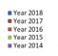
Fig 1: SINGLE most important biomanufacturing trend or operational area, 2014-2018
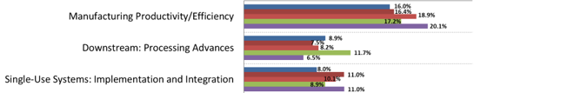
Source: 15th Annual Report Survey Biopharmaceutical Manufacturing Capacity, April 2018, BioPlan Associates, Inc. Rockville MD www.bioplanassociates.com/15th

#2 Trend: Bioprocessing productivity continues to increase
Annual survey data and other sources confirm that bioprocessing efficiency and productivity, in terms of upstream titers and downstream yields will continue to increase. Related to this, bioprocessing professionals and companies must spend increasing time and effort assessing available technologies and manufacturing options to keep their bioprocessing up-to-date and make sure they are actually attaining current industry norms, if not optimum levels, for productivity, product quality and lower costs.

Related survey findings this year include:

- The average titer for reported new commercial-scale monoclonal antibody (mAb) upstream bioprocessing was 3.20 g/L, up from 2.80 g/L last year. Nearly all the other yearly data back to 2008 show consistent incremental increases to the present. In related trade periodical articles, BioPlan has reported incremental increases in titer over the past 3+ decades, starting from at best a few 10ths of a gram/L back in the 1980s.^{1,2}
- The average reported titer for late-stage clinical-scale biologics for new mAb bioprocesses) was 3.20 g/L, with this an outlier or unexpected result, in terms of clinical stage bioprocesses generally being newer and at higher titers than commercial processes, and this data point is less than last year’s reported 3.29 g/L. However, clinical manufacturing titer continues to follow a general pattern of increase since 2008, when the average was 1.96 g/L. The slight decreases over the past 2 years, from a peak of 3.75 g/L reported in 2015, are just incremental, if not outliers, and the trend for improvement is expected to overall continue in coming years.

Fig 2: Range of Titers for mAbs Obtained at Various Production Scales, Distribution
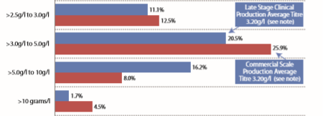

Source: 15th Annual Report and Survey Biopharmaceutical Manufacturing Capacity and Production, April 2018, BioPlan Associates, Inc. Rockville MD , www.bioplanassociates.com/15th

#3 Trend: Biosimilars/biogenerics bringing more products and players
Follow-on biopharmaceuticals is a rapidly growing field. A large number of products are in the development pipeline, with this expected to change biopharmaceutical manufacturing and marketing.^{3,4} The Biosimilars/Biobetters Pipeline Database (www.biosimilarspipeline.com; marketed by BioPlan) reports 940 biosimilars (including biogenerics) in development or marketed worldwide, including 159 in clinical trials. There are also 560 biobetters in development or marketed worldwide, with 217 in clinical trials. Over 750 companies are involved in follow-on (biosimilar, biobetter and biogenerics) products, with many new entrants in both developed and emerging regions. There are also 378 currently marketed follow-on biologics although ~90% of these are biogenerics (e.g., not marketable in U.S., EU and other major GMP markets due to inability to meet current standards, or lacking extensive comparative analytical and clinical testing required to receive approvals in major markets). Most all biogenerics are marketed in lesser-regulated international commerce, in developing countries.⁴

With such a healthy development pipeline, within ≥5 years biosimilars and other new follow-on biopharmaceuticals may outnumber reference and other innovative biopharmaceutical products, even in the U.S. market. This will change the underlying nature of the biopharmaceutical industry. Markets will likely become more competitive and more like generic drugs markets. CMOs are already reporting increased business, about 15% increase in revenue, attributed to biosimilars projects.

Biosimilars (and biogenerics in lesser- and non-regulated international markets) are resulting in a number of new players entering the biopharmaceutical industry, and new manufacturing facilities being constructed. The largest number of biosimilars (i.e., major market-targeted biosimilars) in development and their developers remain in the U.S., with the U.S. still the primary location for biopharmaceuticals R&D and the largest market for biopharmaceuticals. But Europe, India and China are the other major centers for biosimilars development continue to ramp-up their R&D and product portfolios.

Biosimilars are also affecting the bioprocessing industry and its suppliers’ markets. This includes nearly all biosimilar developers using single-use systems as much as possible for manufacturing, including adopting single-use for commercial manufacturing. And as BioPlan has reported, biosimilars involve essentially the same (or rather biosimilar) products competing against each other, their reference products and other products used for the same indications. Marketing will be fiercely competitive, including product costs, and this is forcing developers to adopt optimally efficient bioprocessing technologies. Biosimilar manufacturers, many starting with no biopharmaceutical expertise or infrastructure, are often more receptive to adopting new technologies compared to innovative products developers, mostly well-established large companies, taking more conservative, time-proven approaches.⁵⁻⁷

The figure below shows the number of reference products (the long-marketed model products for biosimilars) by their estimated U.S. marketability date. This is the year in which the reference products come off U.S. market exclusivity, nearly always determined by patent expirations, but also sometimes involving expiration of regulatory-granted exclusivities, including the statutory 12 years of post-BLA marketing exclusivity (no biosimilar version approvals) and 7 years from having received orphan designation.

Fig 3: Number of Biosimilars in the U.S. Pipeline by Launchable Dates
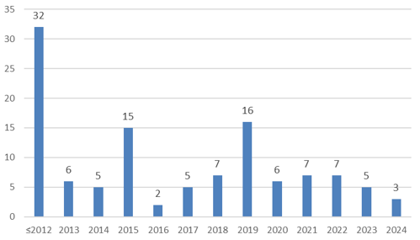
Source: 15th Annual Report and Survey Biopharmaceutical Manufacturing Capacity and Production, April 2018, BioPlan Associates, Inc. Rockville MD , www.bioplanassociates.com/15th

#4 Trend: Facility Constraints creating bioprocessing bottlenecks; continuous DSP a needed response
This year, the top most frequently cited factor reported as likely to cause capacity constraints at respondent facilities in 5 years (2023) was “Facility Constraints,” with this remaining the no. 1 cited factor since asking this question in 2008. Facility constraints were perceived slightly more among U.S. vs. Western European respondents, 52.6% and 50.0%, respectively.

“Develop better Continuous Bioprocessing - DOWNSTREAM Technologies” was the area most commonly cited, by 42.2%, as needing to be addressed by industry (not specific facilities/companies) to address (fix or avoid) future capacity constraints. Product developer respondents cited continuous downstream processing needs significantly more frequently than CMO respondents, 43.7% vs. 31.3%. Further reinforcing that downstream areas are perceived as needing improvements, the 2nd most commonly cited key area to avoid future capacity constraints was “Develop better downstream purification technologies.”

But it is somewhat surprising that respondents would cite continuous downstream processing as presumably making a significant contribution to elimination of bottlenecks, with relatively few bioprocessing professionals having hands-on experience with continuous chromatography or other continuous downstream technologies, and with most industry facilities implementing continuous processing having actually implemented it for no more than a few unit processes.

It has been a general consensus or common knowledge within the industry that downstream (vs. upstream and fill-finish) operations continue to cause most, including the most severe, bioprocessing constraints (bottlenecks). BioPlan has documented rather significant increases over time with industry upstream titers.^{1,2} This includes an order of magnitude greater average titers now vs. several decades ago. At the same time, downstream yields have changed little, from historical ~70% to ~75% currently (for commercial mAb manufacturing). So, downstream bioprocessing needs significant productivity improvements to keep up with constant incremental improvements in upstream processing.

Downstream processing, particularly purification, and within this, chromatography, continues to be the areas cited as responsible for most constraints (bottlenecks) in production. This year, 72.0% of U.S. and 70.9% of Western Europeans survey respondents reported that their facility was experiencing at least some degree of capacity bottleneck. Perceptions regarding experiencing “severe constraints” by U.S.-based respondents were significantly lower this year than for Western Europe, with 2.8% of U.S and 8.9% of European respondents, respectively, indicating their facility is experiencing “severe constraints today”

Chromatography columns remain overall the top-cited downstream (or any) bioprocessing problem area. This included 57.4% of respondents, up from 48.3% last year, citing “Chromatography columns” as causing “Moderate constraints” or worse constraints; and 78.4% citing “Chromatography columns” as causing them any constraints. “Depth filtration,” another downstream process, came in 2nd this year as the most commonly cited cause of bioprocessing constraints.

Overall, CMOs reported lower incidence of currently experiencing either “Severe” or “Significant” capacity constraints at their facilities compared to developers - 13.2% among developers and 9.8% among CMOs. CMOs are generally presumed to experience fewer capacity constraints vs. developer companies, with CMOs only taking on projects they have capacity for and CMOs, by their nature, and being highly adept at rapidly changing-over bioprocessing.

Fig 4: Factors Creating Future Capacity Constraints, in 5 years

Source: 15th Annual Report and Survey Biopharmaceutical Manufacturing Capacity and Production, April 2018, BioPlan Associates, Inc. Rockville MD , www.bioplanassociates.com/15th

Fig 5: Key areas to Address to Avoid Capacity Constraints

Source: 15th Annual Report and Survey Biopharmaceutical Manufacturing Capacity and Production, April 2018, BioPlan Associates, Inc. Rockville MD , www.bioplanassociates.com/15th

#5 Trend: Industry seeks lower manufacturing costs
The bioprocessing industry continues to recognize that success in biopharmaceuticals requires the ability to cost effectively manufacture commercial-scale products. This year, again, a majority of respondents continue to report that their facility has implemented programs to reduce bioprocessing costs. A total of 64.0% reported having “Implemented programs to reduce operating costs” within the past 12 months. The 2nd most commonly cited cost reduction activity in the past year was “Negotiated harder with vendors to reduce costs,” at 41.3%.

Working to reduce bioprocessing costs has become a routine activity. Besides biosimilars and other new product entries increasing competition, other forces are increasing the need to cost-efficiently manufacture products. Pressures for lower costs include high pharmaceutical prices and discounting of biosimilars, with most expecting ~30% discounts relative to reference products in the U.S. market.

This is the first year we surveyed regarding average cost/gram for recombinant protein manufacture. The average reported cost was $306.8/gram for respondents’ primary recombinant protein product, usually a monoclonal antibody.⁷ Somewhat surprising, 17.7% of respondents reported an average cost of <$100/gram for their facility. These lowest costs are generally associated with the very largest facilities, 100,000+ L facilities that have long been paid for; and new super-sized facilities, e.g., Samsung and Celltrion in S. Korea. A slightly smaller percentage reported cost/gram >$1000. These data are reported by bioprocessing professionals, not financial staff. Therefore, actual costs may differ from respondents’ perceptions. However, in future analyses, we expect trend data to present accurate insight into relative cost structure changes.

Hundreds of dollars per gram may sound high for recombinant protein manufacture at commercial scales. But even considering dosages on the high side, e.g., a monoclonal antibody dosed at 100 mg/dose, if each gram costing on average $300/gram (or even $1,000/gram) for manufacture makes 1,000 doses, and presuming a rather low cost of $1,000/dose, each gram can provide $1 million in revenue; a 1,000/1 ratio of bioprocessing costs to revenue. But the ratio of revenue to costs is usually much higher with other, including more potent, products.

Fig 6: AVERAGE cost/gram for Recombinant Protein manufacture
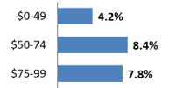

Source: 15th Annual Report and Survey Biopharmaceutical Manufacturing Capacity and Production, April 2018, BioPlan Associates, Inc. Rockville MD , www.bioplanassociates.com/15th
#6 Trend: Healthy Biopharma Industry and Supplier Growth
The biopharmaceutical industry and its supply sectors, both equipment and services, have been growing rather consistently at ~12-14% in terms of revenue over the past 20+ years. Worldwide sales of biopharmaceutical are now over $250 billion. With a very healthy pipeline of innovative and follow-on products and growth in international sales, industry revenue can be expected to further steadily increase and drive further growth in biopharmaceutical R&D and manufacturing.

This year “Equipment and Instrumentation” took the top spot in terms of supplier-employed survey respondents (not bioprocessing professionals), at 16.8%. This replaced “CMOs” last year estimated to have a 24.2% growth rate, with this falling to 7.5% this year. This year, the growth in the “Raw Materials and Consumables” sector was reported at 13.3% and “Services (e.g., CMOs, CROs, consultants)” at 12.1%.

Growth in the bioprocessing supplies market continues to closely track that of growth in revenue and marketed biologics. Suppliers reported an average 13.7% sales growth, a slight reduction from recent prior years. Equipment sales reported the highest revenue growth rate, 16.8%. The industry sector with respondents reporting the highest price increases in the past 12 months were CMOs, reporting an average 9.0% increase. Nearly 60% (59.1%) of supplier respondents companies had bioprocessing sales over $10 million.

The reported growth rates in specific supplies/services areas generally agree with BioPlan long reporting that growth in supplies, both hardware and services, in bioprocessing generally tracks the growth in biopharmaceutical products’ revenue, which remains rather steady at about 12%-14% annually. Supplier sales growth has been and will continue to be largely driven by the movement of new biopharmaceuticals through the development pipeline, and the growth of bioproduction in emerging markets. The bioprocessing supplies market will continue to be a very attractive one, especially in comparison to the life sciences research market, which is ultimately dependent on tax-payer/government funding, with government R&D grants not receiving as high annual increases as in prior recent years.

Fig 7: Average Annual Vendor Segment Sales Growth Rates, 2018

Source: 15th Annual Report and Survey Biopharmaceutical Manufacturing Capacity and Production, April 2018, BioPlan Associates, Inc. Rockville MD , www.bioplanassociates.com/15th
#7 Trend: Bioprocessing budgets continue to increase

Survey results continue to show that companies are investing more in biopharmaceutical R&D and production, including hiring staff and expanding manufacturing capacity. Budgets for new capital equipment continued to be an area of significant growth, with respondents reporting an average increase of 8.2% in facility bioprocessing budgets for 2018. Much of this involves construction of new facilities, retrofitting, and addition of capacity at existing facilities, with this increasingly single-use based. This is a change from about 8-10 and more years ago when bioprocessing budgets showed decreases in key areas ranging from outsourcing production, hiring new scientific staff, to new facility construction. These widespread reductions, mostly associated with the prior worldwide economic downturn, have passed; and respondents have been and continue to indicate that their bioprocessing-related budgets are now continuing to increase annually.

As reported in a related trend, suppliers/vendors are reporting that sales revenue continues to increase, with many of the largest suppliers regularly reporting annual increases of 12%-15%+. The area with the least projected budget growth, but still growing, was outsourced biopharmaceutical manufacturing.

It is very significant that this year no budget decreases were reported in any of the areas surveyed, confirming an overall increase in bioprocessing budgets among developer companies.

Fig 8: Approximate Average Change in Biomanufacturers’ Budgets for 2018

Source: 15th Annual Report and Survey Biopharmaceutical Manufacturing Capacity and Production, April 2018, BioPlan Associates, Inc. Rockville MD , www.bioplanassociates.com/15th
#8 Trend: Single-use systems use still growing

Single-use equipment continues to make advances into biopharmaceutical manufacturing, and is becoming increasingly common in most areas, particularly at pre-commercial scales (e.g., clinical and preclinical) where single-use systems dominate stainless steel systems, especially upstream. BioPlan estimates that ≥85% of pre-commercial product manufacturing now involves primarily single-use systems manufacture, particularly upstream manufacturing. Single-use systems adoption will increase as more new products now being developed using single-use systems move through the development pipeline, to clinical scale manufacturing and on to cGMP commercial production using single-use systems.

Again, this year over 90% of respondents reported currently using single-use bioprocessing equipment, with “Tubing or disposable operations” alone cited the most at 90.6%, followed by “Disposable filter cartridges”, used by 86.2%, and “Bags, empty” used by 81.8%. In terms of major equipment indicative of a fully or substantially single-use-based facility, over 3/4 (76.7%) reported use of single-use bioreactors, with nearly one-half (46.5%) reporting any use of perfusion bioreactors. Reported annual growth (adoption) rates in single-use systems usage, in terms of their first usage within the facility (not growth in revenue) was highest, 18.6%, for “Perfusion devices, followed by “Membrane adsorbers” at 13.6%, “Mixing systems” at 11.6%, and growth in use of single-use bioreactors at 11.4%.

CMOs reported overall higher percentages of use of single-use vs. stainless steel bioprocessing supplies. CMOs reported higher incidence of use of single-use equipment vs. developer facilities among 13 out of 15 (97%) product areas surveyed. CMOs using single-use systems more vs. developer companies is fully expected. CMO have greater needs for flexible production capacity, fast campaign change-overs, must make more products as rapidly as can be done at varying scales, and also tend lack legacy production systems, so they tend to adopt new technologies quicker than developers.

Fig 9: Usage of Disposables in Biopharmaceutical manufacturing, any Stage of R&D or Manufacture

Source: 15th Annual Report and Survey Biopharmaceutical Manufacturing Capacity and Production, April 2018, BioPlan Associates, Inc. Rockville MD , www.bioplanassociates.com/15th
#9 Trend: Continuous bioprocessing innovation in demand

This year when asked what bioprocessing innovations are most needed, respondents continue to very frequently cite aspects of continuous bioprocessing. For example, when asked to identify the top areas where suppliers should focus their development efforts, the 2nd-most cited area was “Continuous bioprocessing-downstream, chromatography,” citing by over 1/3rd (37.8%), up from #3 position in 2017 (33.8%), with this following Disposable/Single-use: Purification at the no. 1 position (40.6%). After continuous processes at no. 2, the frequency of citation falls dramatically, e.g., with the 3rd-ranked area (Virus filtration) at 26.1%. Continuous bioprocessing is the area in which they see need for improvements to resolve downstream problems, including difficulties keeping up with increasingly efficient upstream processing. Continuous bioprocessing is often cited in other questions as an option for resolution of bioprocessing problems, and continues to be a major area for optimism, and hopes that these systems will become available and adoptable for mainstream bioprocessing, including GMP commercial manufacturing. Upstream perfusion has been around for decades, even available in single-use formats; downstream bioprocessing, on the other hand, particularly chromatography systems are just starting to enter the market. Perfusion at larger scales has remained mostly limited to use of stainless steel equipment and essentially only adopted by a small core of well-established major facilities often now having used it for decades, such as for manufacture of recombinant Factor VIII and other sensitive proteins. Many bioprocessing professionals also see risks in continuous processing (discussed below). In terms of continuous chromatography, and relevant systems are only just starting to enter the market. A few Big (Bio)Pharma companies are still implementing a few key unit processes in genuine continuous mode. But BioPlan expects to see fully continuous processing at commercial scales, including single-use systems, in the next 5-10 years. In terms of upstream perfusion, the most advanced part of continuous bioprocessing, the survey continues to show that bioprocessing professionals have lingering doubts. When asked to cite aspects of continuous processing where they have greater concerns vs. fed-batch processing, the top 3 concerns overall were “Process development control challenge” (68.9%), “Process operational complexity” (65.2%), and tied at third position: “Need for greater process control” and “Validation challenges,” (63.4%), Very significantly, higher concerns with perfusion vs. fed-batch were reported for all of the 19 aspects surveyed.

Fig 10: Concerns Over Perfusion Processes vs. Batch-fed Processes in Bioprocessing
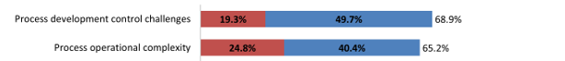
Source: 15th Annual Report and Survey Biopharmaceutical Manufacturing Capacity and Production, April 2018, BioPlan Associates, Inc. Rockville MD , www.bioplanassociates.com/15th
#10 Trend: Bioprocessing capacity growing, particularly in Asia; cell therapy capacity shortages exist

BioPlan’s free www.Top1000Bio.com database reports and ranks the top 1,000+ biomanufacturing facilities worldwide in terms of known or estimated cumulative bioreactor capacity, along with employment and number of products manufactured commercially and at clinical scales. The database now tracks over ~16.2 million L of active production capacity at over 1,500 facilities worldwide, involving recombinant products, non-recombinant biopharmaceutical vaccines and blood/plasma-derived products. Overall breakdown of worldwide bioprocessing capacity includes:

- 6 million L (37%) in the US/Canada
- 5.5 million L in W. Europe (33%)
- 4.7 million L (25%) in Asia Pacific
- 876 thousand L in China, and
- 833 thousand L in India.

Capacity factors include: single-use process lines making adding capacity relatively quick, ample capacity available, particularly among largest (multiple >10,000 L bioreactors) facilities, titer and yield improvements; and continued investments in new facilities. Given these factors, there is currently no ongoing bioprocessing “capacity crunch,” nor is any expected to affect mainstream bioprocessing. This year, only 10.5% reported “Severe constraints” at commercial manufacturing scales, with even lower rates reported for earlier-phase development. “Capacity crunches” may be concentrated in specific segments, such as cellular and gene therapies manufacturing, where current manufacturing capacity is at severe deficit; i.e., 5x current capacity could be in use currently if it existed.⁸ BioPlan studies have shown that nearly 90% of cell therapy developers would prefer to manufacture using CMOs, but most are not finding the expertise or facilities, and there is an average ≥18 months wait time to get started.

New facilities construction and expansions continue in major markets, and growth in capacity involving commercial scale stainless steel continues. But overall the fastest growth (from low baselines) is in Asia, particularly China.⁹ This includes contract manufacturing organization (CMO) capacity growth in China, especially as regulations are changing so 3rd parties can manufacture biopharmaceutical supplies. Based on our studies, China also appears to rapidly be adding new capacity and modern bioprocessing technologies. Chinese companies, with loans and grants from the central, and local governments, are orienting themselves to be major players in GMP manufacturing, global and innovative products development and manufacturing. China now has over 50% more facilities than India, although the average facility size is significantly smaller. The largest Chinese facility with <80,000 L capacity, is rather small by monoclonal antibody manufacturing standards. Much of India’s biologics capacity involves larger vaccines facilities.
#11 Trend: Hiring in bioprocessing a continuing problem

Hiring of bioprocessing professionals continues to remain a problem area, and will likely only get worse in coming years. Problems involve replacing many of the most experienced and senior staff, the baby-boomers starting to retire, and a related shortage of available experienced bioprocessing professionals. Staff are needed for new facilities, and experienced staff are needed in new areas, such as biosimilars, cell and gene therapies; and the industry continues to expand, including new facilities in major markets and also developing markets, notably China and other Asian markets.

Concerns and problems with staffing are troublesome particularly concerning process development staff. As in prior years, hiring of process development professionals, continues to be the most commonly cited area in which facilities are reporting difficulty filling positions. “Process development staff, upstream” was the number 1 most difficult to fill area, cited by 40.8% (51.2% in 2017, and 36.4% in 2016). “Process development staff, downstream” came in very close at 40.0% this year (53.6% in 2017, and 35.1% in 2016). Both categories remain at the top of the list since 2011. “Process engineers”, with 21.5% of respondents now reporting vs. 33.3% in 2017, was third, followed by “Upstream operations staff” at 19.2% compared to 33.3% in 2017.

Facilities in Western Europe are reporting more hiring difficulties than in U.S. Among Western Europe respondents, 52.0% reported difficulties in hiring upstream process development staff, compared to 40.2% for U.S. respondents. Similarly, formulation process development staff hiring difficulties were reported by 24.0% of Western European and 15.9% of U.S. respondents.

Finding bioprocessing and cell culture process specialists with high levels of expertise has always been a challenge; and, despite continued demand and even shortages, no major training initiatives or changes appear to be occurring. This includes no major training/education initiatives by or targeting the industry or even just bioprocessing. The difficulties in hiring may well reflect more facilities seeking to hiring relatively more highly-qualified employees. The experience levels required appear to overall be increasing, as bioprocessing, quality assurance, regulations, etc., only ever become more complex.

Fig 11: Areas Where Hiring Difficulties Exist in Biopharmaceutical Operations

Source: 15th Annual Report and Survey Biopharmaceutical Manufacturing Capacity and Production, April 2018, BioPlan Associates, Inc. Rockville MD , www.bioplanassociates.com/15th
#12 Trend: Fill-finish operations are advancing

Fill-finish has long been considered a relatively less dynamic part of biopharmaceutical manufacture in terms of innovation and major upgrades in technologies and operations. One reason for this is that the product is at its most valuable when reaching this point, and current fill-finish equipment are generally adequate. But this is changing as technological advances improve fill-finish productivity and quality.

In our study, “Introduction of RABS and Isolators” was the “most important trend” in biopharmaceutical fill-finish in 2017 (when fill-finish trends questions were last asked), and was cited by an unusually high 90.0% of all respondents, with this approximately double the 45.5% response reported a year before. “Facilities becoming more multi-product-use oriented” is also another trend, cited by 80.0% of respondents. It is very rare to see such high levels of agreement, indicating these trends essentially universal.

Other most important trends cited by respondents included “More innovation for Fill and Finish equipment,” cited by 50%; “Isolator units and automation moving down in scale,” cited by 40%; and “Potent compound handling,” cited by 30%. “Single-use/disposable equipment adoption” in fill-finish continued to be seen as a trend, with 60.0% of respondents reporting this a most important trend.

Otherwise, fill-finish facilities and process lines generally remain dedicated to serving both pharmaceuticals and biopharmaceuticals, with many facilities and even process lines handling both. There are few CMOs specializing in biopharmaceutical F-F operations. CMOs with specialized biopharmaceutical fill-finish expertise are becoming increasingly needed in new areas, including gene and cellular therapies, and antibody-drug conjugates (ADCs) and other highly potent APIs/products.

In terms of facility plans for upgrading their fill-finish operations within the next 24 months, the largest portion, 40.0%, cited “Single-use fill-finish devices;” 40.0% also citing “Isolator Line (New facility),” and 30% cited “RABs Line (Existing facility).”

Fig 12: Most Important Trends in Fill-Finish, 2015-2017

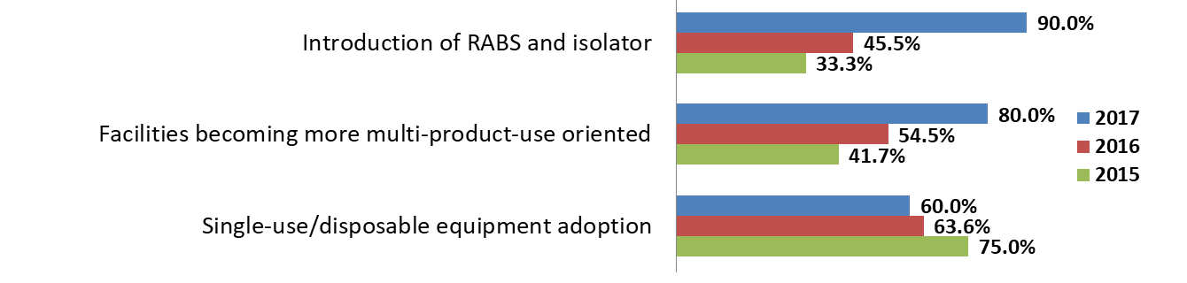
Source: 15th Annual Report and Survey Biopharmaceutical Manufacturing Capacity and Production, April 2018, BioPlan Associates, Inc. Rockville MD , www.bioplanassociates.com/15th
#13 Trend: Analytical assays a top area needing improvement

This year when respondents were asked to cite the areas in which “TOP areas suppliers should focus their development efforts on,” the largest portion, 41.5%, cited “Analytical assays.” This was a historical high level of response reported for any area since starting to ask this question in 2010. Respondents from CMOs reported slightly more interest in improvements in “Analytical assays” than those with developer companies, 43.8% vs. 41.3%. Significantly more Western European, than U.S., respondents cited “Analytical assays,” 51.3% vs. 36.4%, respectively. This compares with 45.2% of respondents in the “rest of the world” or developing countries citing “Analytical assays,” with this tied with “Validation services” as the top areas cited by ROW respondents as most needing supplier development efforts.

The area’s 2nd most cited as needing top suppliers to focus development efforts on was “Validation services,” at 30.3%, with this also making considerable use of analytical and bioassays, up significantly from 15.2% last year. The 3rd most cited area needing improvements was “Automation instrumentation.” The areas least cited as needing development efforts by supplier employees surveyed, all below 10%, included “CMO services - commercial manufacturing” at 7.9%; “Services: Formulation” at 9.0%; and “CMO services - non-GMP/mid- or preclinical scales” at 9.0%.

Fig 13: General (Other) New Product Development Areas of Interest (Biomanufacturers & CMOs, 2018)

Source: 15th Annual Report and Survey Biopharmaceutical Manufacturing Capacity and Production, April 2018, BioPlan Associates, Inc. Rockville MD , www.bioplanassociates.com/15th
#14 Trend: China on track to become an industry leader

Significant growth and changes in the biopharmaceutical industry appear to be occurring in mainland China. As discussed above, China has recently moved ahead of India in terms of raw bioprocessing capacity⁹. A survey of 50 biopharmaceutical manufacturing executives in China by BioPlan staff in China show that Chinese companies are working towards eventually developing a biopharmaceutical industry that will not only serve the country’s massive domestic market, but also compete in major world markets for innovative products manufactured at GMP quality.

Among the Chinese respondents, 58.0% cited current need to develop a “more innovative biopharmaceutical pipeline” as the leading response when asked to cite what China must possess to expand globally. This was followed by 50.0% citing both need to develop an “Overall quality image” and “Capacity, commercial scale.” When asked to cite, “What China needs to be competitive as a global biopharma center in 10 years,” the overwhelming response, from 76%, was “More innovative biologics/more R&D.” At far lower levels, the 2nd most cited response was “Improve legal/regulatory compliance” at 44%; and at 3rd position was “Better quality management systems” at 20%, with all the other >30 selectable options cited by ≤14%. But with China, including with considerable government support and coordination, still just getting started in innovative biopharmaceutical R&D and with product development typically taking a decade or more from inception to approval, it will take time for China’s increasing orientation to innovative products to evolve and enter world markets.

Reflecting the rapid changes expected in China, Chinese bioprocessing respondents noted expectations for serving domestic and global markets in 10 years, with 92% citing expectations of manufacturing for the domestic market and 85% citing expectations for serving global markets in 10 years. With a very large domestic market increasingly demanding biopharmaceutical products; with most current domestic products being biogenerics and classic biologics, e.g., vaccines, and with growth in this market 15%-20% annually, China will see dramatic growth in both its domestic and worldwide biopharmaceutical markets, both follow-on and innovative products.

Fig 14: Top “Strength” Attributes Required for China’s Biologics Companies to Expand Globally

Selected attributes

Source: China Research, BioPlan Associates, Inc. Rockville MD,

In terms of how China has moved toward modifying their quality image, and ability to deal with intellectual property, one question in the 15th Annual Survey dealt with outsourcing destinations. Just 10 years ago, in 2009, China was near the bottom of the list of destinations that US companies would consider, with only 2.8%. This year, China is the top destination with 25.4% of respondents considering it at least a likely destination for outsourcing in 5 years.

Fig 15: Top Destinations for US Companies to Consider International Outsourcing:
"Strong Likelihood" or "Likelihood" "Where have you been considering production outsourcing outside your own country over the next 5 years?"
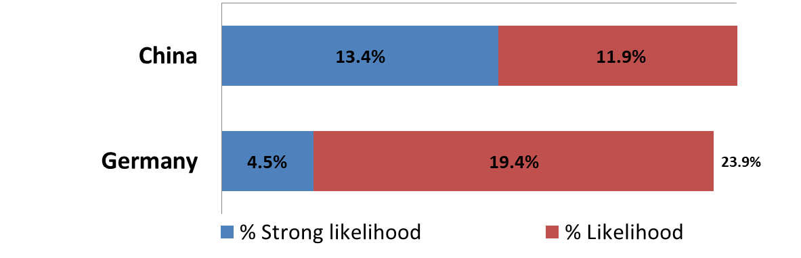
Source: 15th Annual Report and Survey Biopharmaceutical Manufacturing Capacity and Production, April 2018, BioPlan Associates, Inc. Rockville MD , www.bioplanassociates.com/15th
#15 Trend: Changing concerns when selecting a CMOs

Over the past 12 years, there have been significant shifts in concerns when selecting a CMO. Overall, the top concerns in selecting a CMO include:

- Establish a good working relationship
- Stick to a schedule
- Protect intellectual property
- Effectively handle cross-contamination issues

However, when we review the 3 top concerns with the most changes in reporting frequency since starting to ask this question in 2006 we find “Effectively handle cross-contamination issues,” increased by 33.2% percentage points; “Provide lead times sufficient to cover technology transfer,” increased by 22.6%; and “Protect intellectual property,” increased by 21.4%. No other concerns attained more than 10%-point increase over this time period among the 19 options selectable.

“Effectively handle cross-contamination issues,” had its lowest point of 20.3% in 2007. The largest decrease (in attitudes regarding “very important” factors) from last year was with “Protect intellectual property,” which last year was in #1 position at 71.6%, but now in 2018 has fallen ~20% to 51.4%. The reduction in concerns regarding IP may be the result of the experience CMOs have gathered over the decades in this area.

Otherwise, the availability of CMO capacity has apparently remained relatively steady and is not a major problem for the CMOs or clients. CMO capacity was cited as a problem area by only 4.3% of developer company respondents. On the other side, CMO respondents expressed concerns, cited by all (100%) of CMO respondents as either ‘Very Common’ or ‘Somewhat Common,’ was “Clients want to contain cost by limited development runs, but still expect successful full-scale manufacturing,” up from 91.7% in 2013. The second most commonly cited problem was, “Clients don’t build in sufficient time for the project (unrealistic timeframes),” up from 91.7% in 2017 to 92.3%.

Fig 16: Important Outsourcing Issues: Response Shifts Over Time 2006-2018, Percentage Point Differences
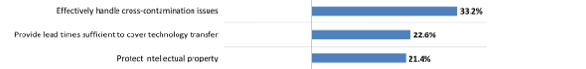
Source: 15th Annual Report and Survey Biopharmaceutical Manufacturing Capacity and Production, April 2018, BioPlan Associates, Inc. Rockville MD , www.bioplanassociates.com/15th

Cited references:

- Rader, R.A., Lander, E.S., “Thirty Years of Upstream Productivity Improvements," BioProcess International, 14(2), Feb. 2015, p. 10-14.
- Rader R.A., Langer E.S., “Biopharmaceutical manufacturing: historical and future trends in titers, yields, and efficiency in commercial-scale bioprocessing,” BioProcess J., 2015; 13(4): 47–54. [note primarily concerns monoclonal antibody manufacturing].
- Rader, R.A., "Analysis of the U.S. Biosimilars Development Pipeline and Likely Market Evolution,” BioProcess International, vol. 11, no. 6, Biosimilars supplement, June 2013, pp. 16-23.
- "Biosimilars in the Rest of the World: Developments in Lesser-Regulated Countries," BioProcessing J., 12(4), Winter 2013/2014, p. 41-47
- "Biosimilars Paving The Way For Cost-Effective Bioprocessing," Biosimilar Development, Aug. 23, 2017.
- Future Manufacturing Strategies for Biosimilars." BioProcess Intl., May 2016.
- "Biosimilars Improving Efficiency, Cost for All Biologics," Contract Pharma, April 2015, p. 28-30.
- Rader, R.A., Cell and Gene Therapies: Industry Faces Potential Capacity Shortages," Genetic Engineering & Biotechnology News (GEN), 37(20), Nov. 15, 2017.
- Xia, V.Q., et al., Directory of Top 60 Biopharmaceutical Manufacturers in China, 2nd edition, BioPlan Associates, Feb. 2017, 357 pages
______________________________________________________

For more information on the 15th Annual Report and Survey of Biopharmaceutical Manufacturing Capacity and Production

Call: 301-921-5979

BioPlan Associates, Inc

2275 Research Blvd, Suite 500

Rockville, MD 20850 USA

Visit www.bioplanassociates.com/15th
Email: orders@bioplanassociates.com

